Abstract Example for ICPSD 2014 Conference
Amir M. Ali¹, Farid R. Qasim²
¹ Department of Physics,My University, City, Province, Iraq
Email: amirm@yahoo.com, web site: http://www.physics.alnahrainuniv.edu.iq
²Department of Chemistry, His/her University, his/her Province, Jordan

Abstract title, authors’ names and their affiliations should be formatted as shown above. Abstract paragraph should be formatted using Times New Roman, size 12 regular and single spaced lines. The final abstract should be saved either in “*.doc” or “*.docx” format of Microsoft Word. Each abstract should not exceed two pages including references. One or two figures, expressing the main results may be included in the abstract. Please follow abstract guidelines when preparing your abstract. Please make sure that the presenting author or the corresponding author is designated with detailed contact information, including at least his/her email address. [1]
Figure 1 shows Al-Madrasah Al-Mustansiriya in Baghdad. It was one of the most prominent and oldest premises of Islamic Universities in the world. It was established by the Abbasid Caliph Al-Mustansir in 1227 on the left bank of the Tigris (Dijlah) river. The building survived the Mongol incursion in 1258 and was restored. Its library collection was said to have grown to 80000 volumes or more. In 1235, an early monumental water-powered alarm clock that announced the appointed hours of prayer and the time both by day and by night was completed in the entrance hall of the Mustansiriya Madrasah in Baghdad. [2]

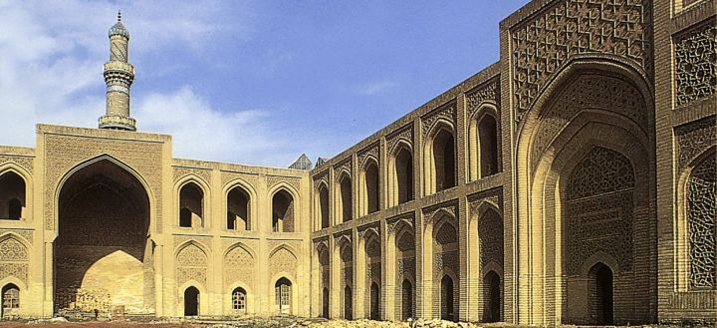
Fig1. The Oldest Islamic University of the Islamic Empire.

- A. J. Mousa and R. H. Mehdi, Journal title 1, (2013), 244-248.
- Donald R. Hill (1991), "Book title", Cambridge University Press 1: 167–186.

Keywords: Provide 3 to five keywords

Presentation Method (Invited talk / Oral presentation/ Poster Presentation):

